**Submission Deadline: January 30, 2023, Monday, 11:59 PM**

**Personalised Parameters:**

See [this Google Sheet](https://docs.google.com/spreadsheets/d/1W7ttHCuQ8RWvopPqVLOiZcBU8eGqEW7H3JVR6px6ogY/) to know your parameters.

**Wireless MAC Type:**

* Wireless 802.15.4
* Wireless 802.11

**Routing Protocol:**

* DSDV
* AODV
* DSR

**Agent + Application:**

* UDP + Exponential Traffic
* UDP + CBR Traffic
* TCP Reno + FTP
* TCP Tahoe + Telnet,

**Node Positioning:**

* Random (Randomly place nodes anywhere with area)
* Grid (Place nodes in a grid. You can choose the number of rows and columns yourself)

**Flow:**

* Random Source Destination (For each flow, choose a random source and a destination. Careful not to choose same node as source and destination)
* 1 Source, Random Sink (except source itself) (Choose a random source X, then for each flow choose X as source, and any other node as destination)
* 1 Sink, Random Source (Choose a random sink X, then for each flow choose X as destination, and any other node as source)

**Parameters:**

Queue: Droptail, max size 50 *(Using Queue/DropTail/PriQueue with DSR may cause segmentation fault. In that case you can use CMUPriQueue instead.)*

Antenna: Omni Directional

Speed of nodes: Uniform random between 1m/s and 5m/s for each node.

Propagation Model: Two Ray Ground Propagation Model

With your personalised parameters and global parameters fixed, vary the parameters below.

**Baseline Parameters:** (while varying one parameter, keep other parameters fixed like below)

* Area Size: 500m x 500m
* Number of Nodes: 40
* Number of flows: 20

**Vary parameters:**

* Area Size: 250m x 250m, 500m x 500m, 750m x 750m, 1000m x 1000m, 1250m x 1250m
* Number of Nodes: 20, 40, 60, 80, 100
* Number of flows: 10, 20, 30, 40, 50

**Metrics:**

For each of the varying parameters, plot 4 graph showing,

* Network throughput
* End-to-end delay
* Packet delivery ratio (total # of packets delivered to end destination / total # of packets sent)
* Packet drop ratio (total # of packets dropped / total # of packets sent)

**For example:**

Say, for varying area sizes, keep other params fixed as mentioned in baseline. Find 4 metrics for each of the values of area size. Plot each metric in a separate graph. You will get 4 graphs for varying area size. One of them is the Delivery ratio. It may look like this. **Clearly mention the x-axis, y-axis, x-ticks and y-ticks.**

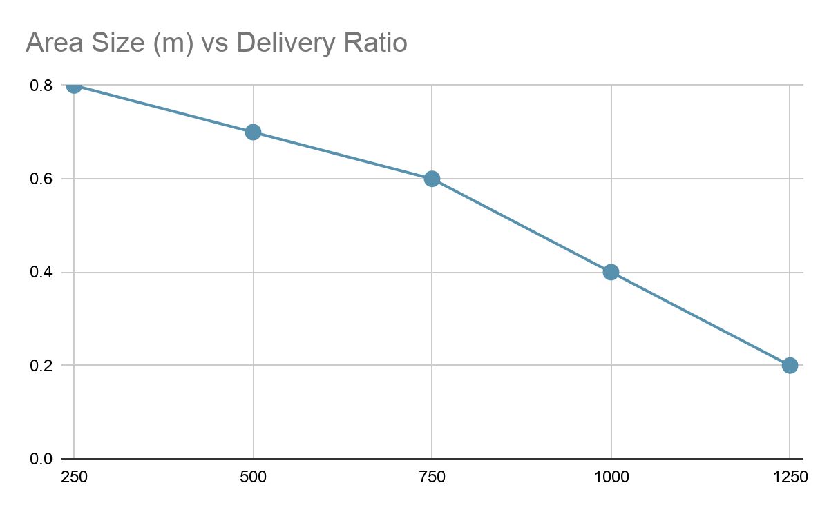

The total number of graphs will be 3 x 4 = 12.

**Report:**

* Write short descriptions of your MAC type, Routing protocol, Agent Type, Application.
* Include all the 12 graphs.
* Write short observations on the results you got.

**Submission:**

* Code (exclude the trace files, nam files). Include only the source files (.tcl, .sh, .awk, .py, .ipynb or others)
* Report as pdf.
* Put all of these in a zip file
* Name it as your student id (1805xxx.zip)
* Submit

**Marks Distribution:**

| Basic Simulation and configs | 4 |
| --- | --- |
| Vary area size + graph | 4 |
| Vary number of nodes + graph | 4 |
| Vary number of flows + graph | 4 |
| Report | 4 |
| **Total** | **20** |

**Appendix A: List of graphs**

| **Graph No.** | **x-axis** | **y-axis** | **Fixed Param Values** | | |
| --- | --- | --- | --- | --- | --- |
| **Area-size** | **Number of nodes** | **Number of flows** |
| 1 | Area Size   * 250m x 250m * 500m x 500m * 750m x 750m * 1000m x 1000m * 1250m x 1250m | Network throughput | - | 40 | 20 |
| 2 | End-to-end Delay | - | 40 | 20 |
| 3 | Packet delivery ratio | - | 40 | 20 |
| 4 | Packet drop ratio | - | 40 | 20 |
| 5 | Number of nodes   * 20 * 40 * 60 * 80 * 100 | Network throughput | 500m x 500m | - | 20 |
| 6 | End-to-end Delay | 500m x 500m | - | 20 |
| 7 | Packet delivery ratio | 500m x 500m | - | 20 |
| 8 | Packet drop ratio | 500m x 500m | - | 20 |
| 9 | Number of flows   * 10 * 20 * 30 * 40 * 50 | Network throughput | 500m x 500m | 40 | - |
| 10 | End-to-end Delay | 500m x 500m | 40 | - |
| 11 | Packet delivery ratio | 500m x 500m | 40 | - |
| 12 | Packet drop ratio | 500m x 500m | 40 | - |